POI Process
POI is calculated each month by Continuous Improvement for orders shipped the prior month. These calculations come from data pulled from NetSuite combined with data provided by Supply Chain Management. Once the POI is calculated for the previous month, the results are sent to the Advantus Management team. The following are the steps for calculating the previous month’s POI.
Step | Action
1 | SCM emails the previous month’s POI data to the POI shared mailbox by the 12th of the month.
2 | CI accesses POI SharePoint folder on Advantus Compliance page  Advantus Compliance/Documents/POI/POI  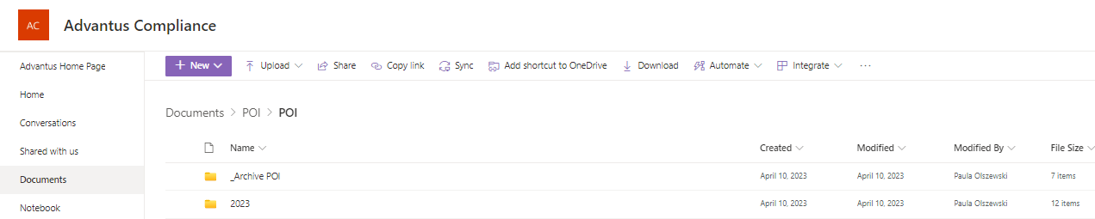
3 | CI selects the correct year for the data that is to be calculated  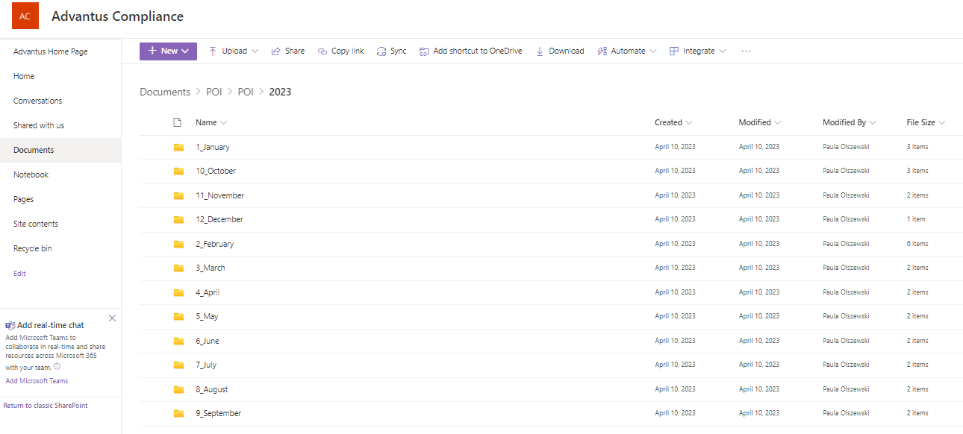

Step | Action
4 | CI selects the folder for the last calculated month to copy the POI spreadsheet (Example: If trying to calculate December 2023 POI, would select 11_November folder as that was the last completed calculated month.)  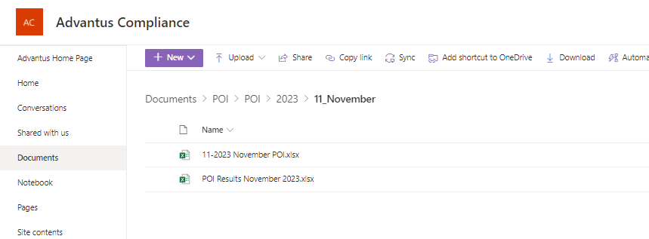
5 | CI selects the completed MM_YYYY Month POI.xlsx document in the folder and selects the Copy to option  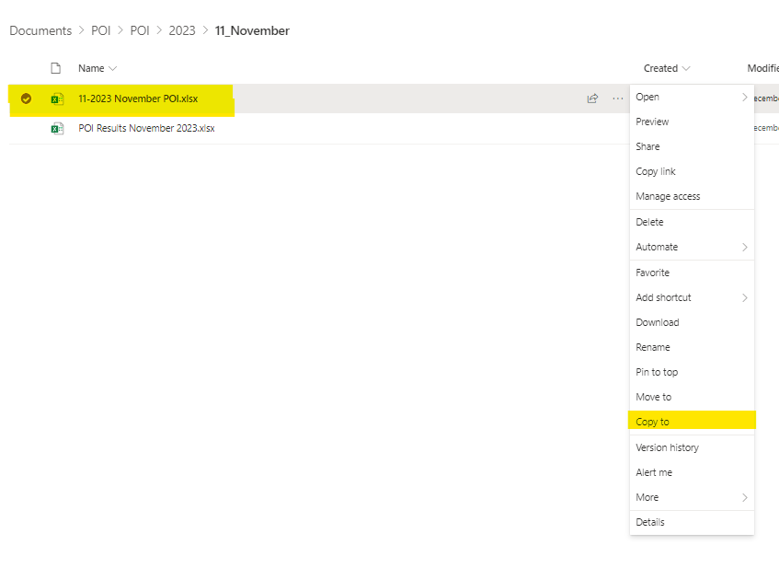

Step | Action
6 | CI navigates to the POI folder that matches the year and month that is currently being calculated and clicks Copy here option (Example: If trying to calculate December 2023 POI, would select 12_December POI folder.)  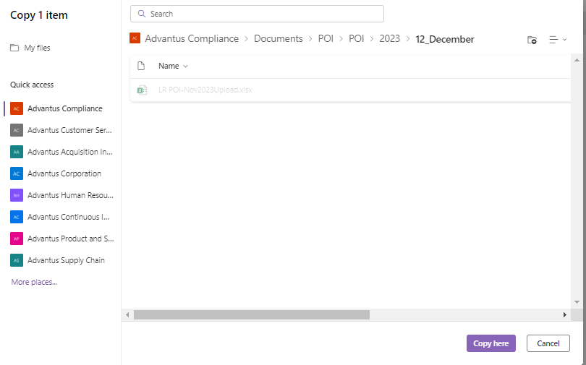
7 | CI selects newly copied document and then the Rename option  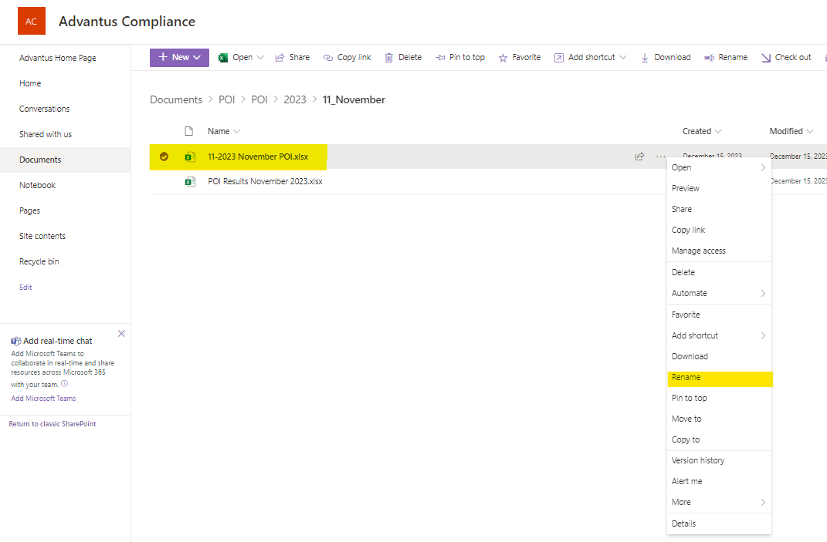

Step | Action
8 | CI renames the document to MM-YYYY Month POI.xlsx for the month to be completed  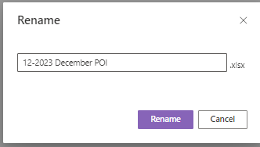
9 | CI opens the newly renamed spreadsheet to begin calculations  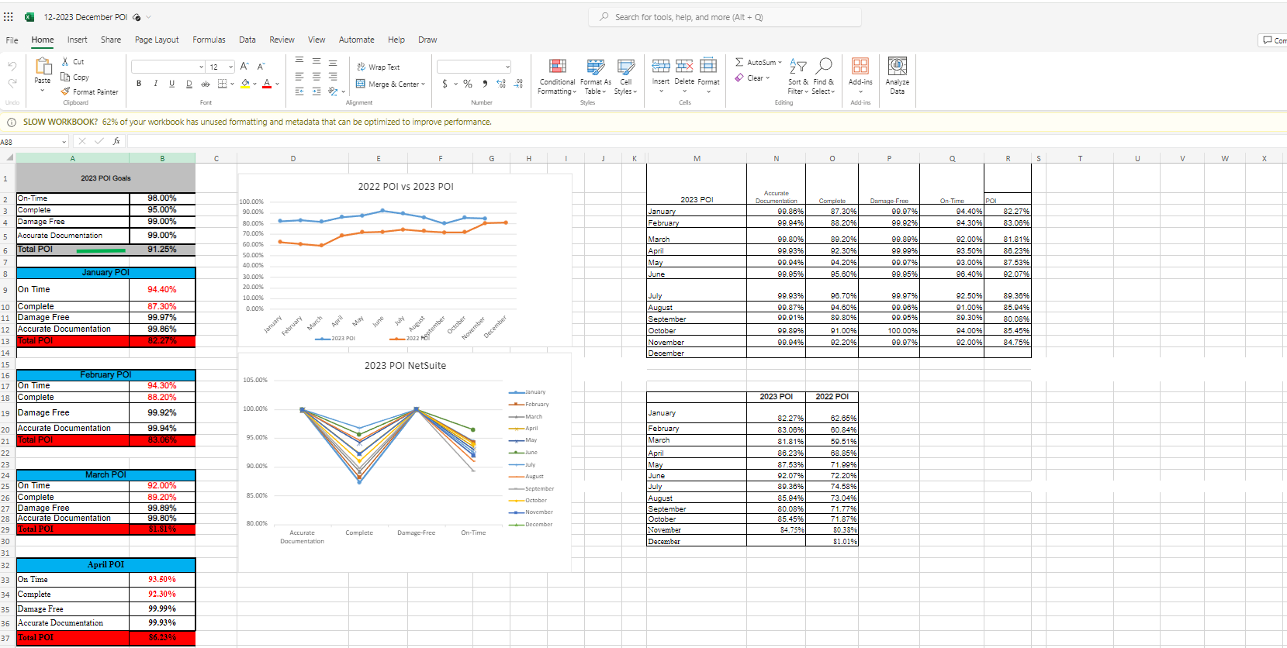

Step | Action
10 | CI scrolls down to last completed Month summary and copies, then pastes it right below  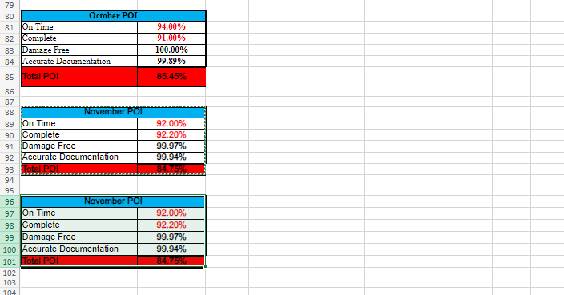
11 | CI renames month to calculating month and removes all data  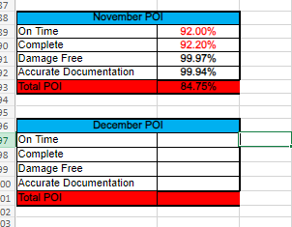

Step | Action
12 | CI logs into NetSuite selects Compliance center, POI then POI Overall function  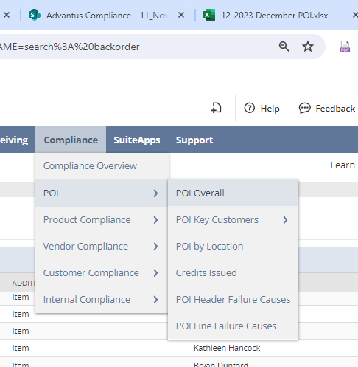

Step | Action
13 | CI records the data in % ON-TIME and % COMPLETE columns in NetSuite for the calculating month into the corresponding cell on the POI spreadsheet  NetSuite Data:  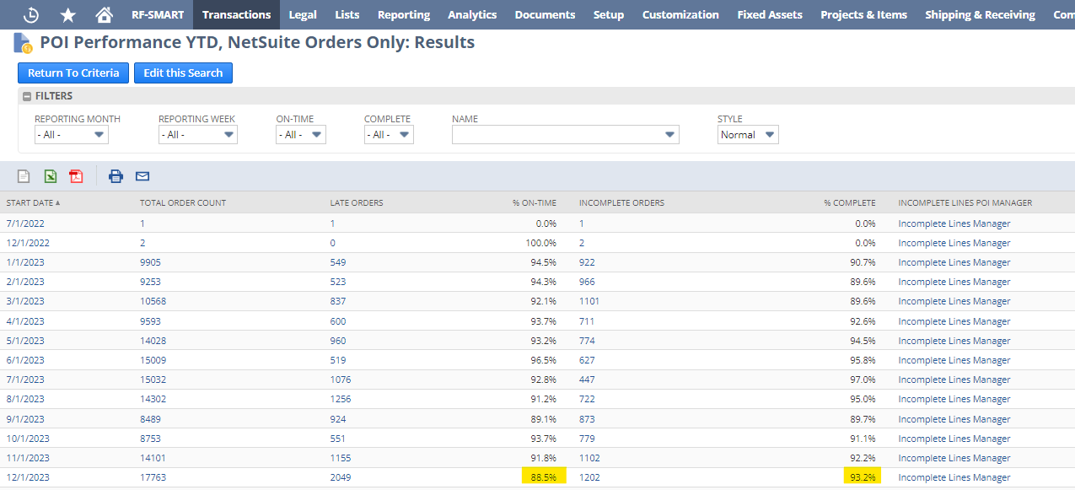  POI Spreadsheet:  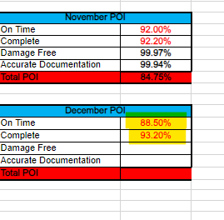

Step | Action
14 | CI opens the POI email from SCM for the calculating month and copies the attachment into the Year, Month POI folder in SharePoint.  Email:  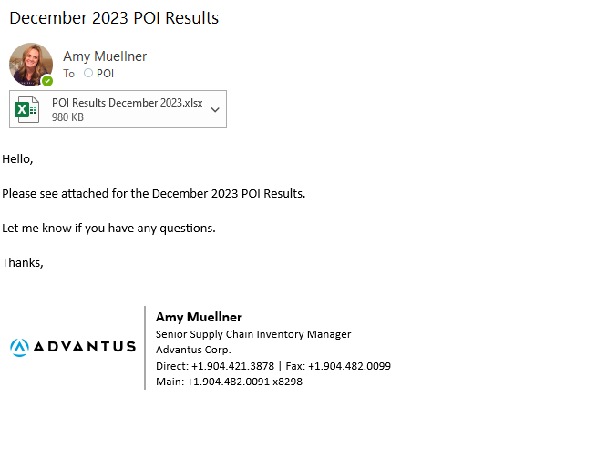  SharePoint folder:  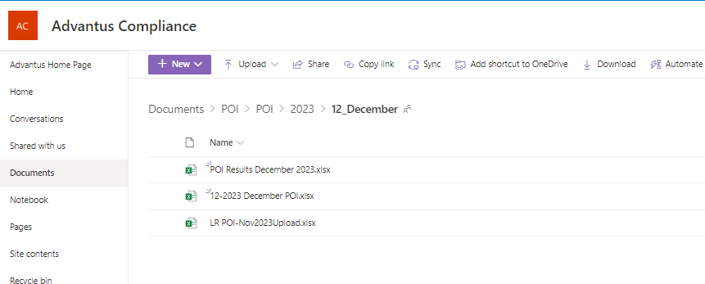

Step | Action
15 | CI opens the POI Results spreadsheet from SCM  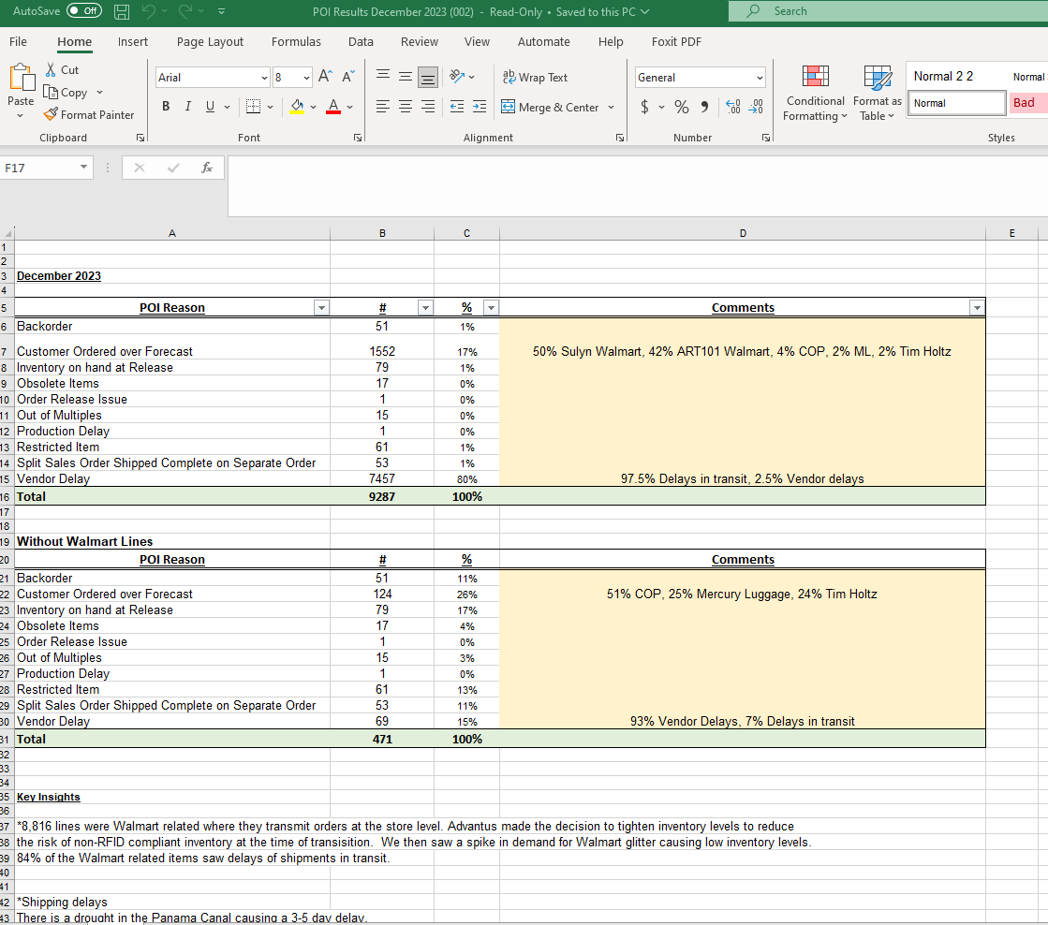
16 | CI copies the data on the complete POI tab from SCM spreadsheet onto the Complete – NS tab of calculating month’s POI spreadsheet  SCM spreadsheet tab:  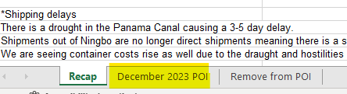  POI spreadsheet tab:  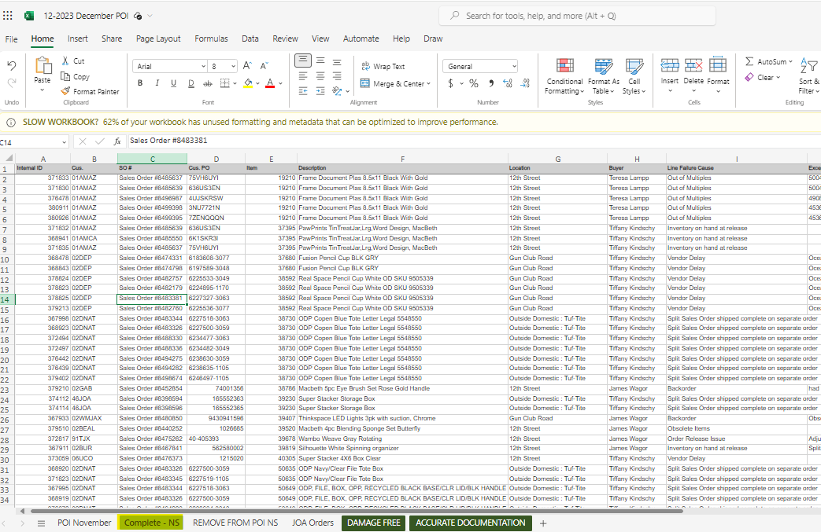

Step | Action
17 | CI copies the data on the Remove from POI tab from SCM spreadsheet onto the Remove from POI NS tab of calculating month’s POI spreadsheet  SCM spreadsheet tab:  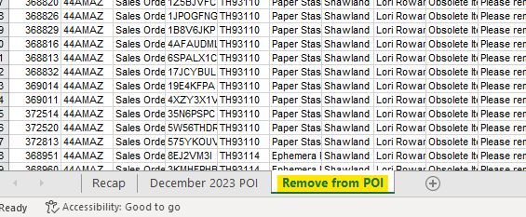  POI spreadsheet tab:  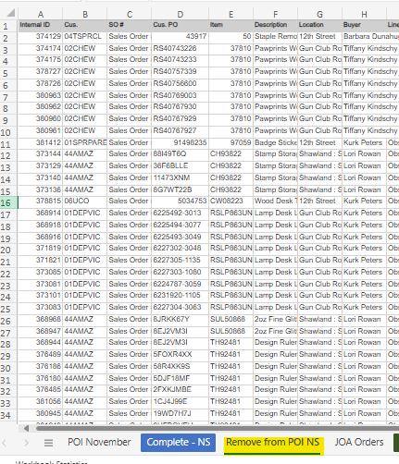

Step | Action
18 | CI accesses Compliance center, POI, Credits Issued in NetSuite  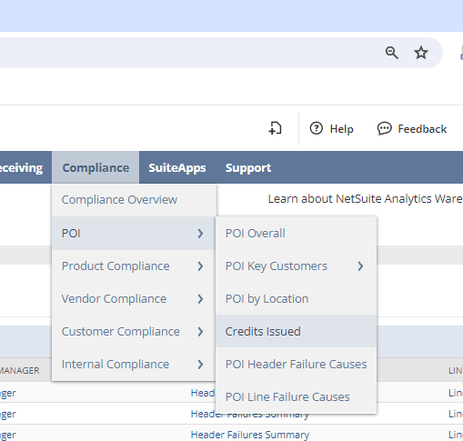
19 | CI updates the following filters on the Credits Issued report and then selects Refresh  Credit Memo Reason: C/S – Defective from Manufacturer  From: First day of the calculating POI month  To: Last day of the calculating POI month  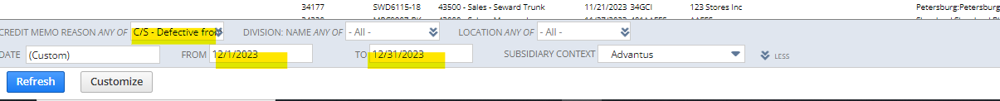

Step | Action
20 | CI exports returned report data into Excel and copies data  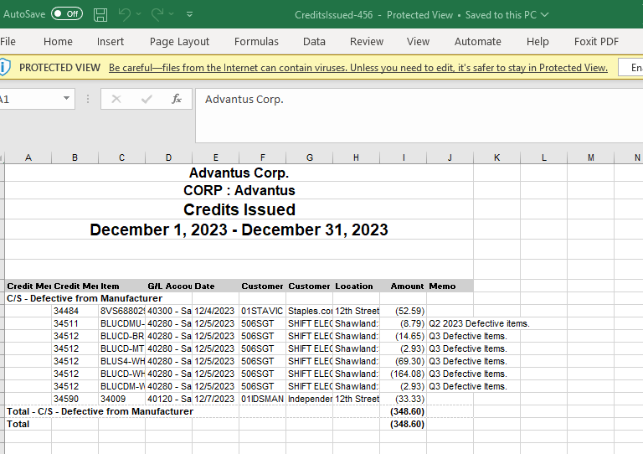
21 | CI pastes Credit Issued data onto Damage Free tab on POI spreadsheet  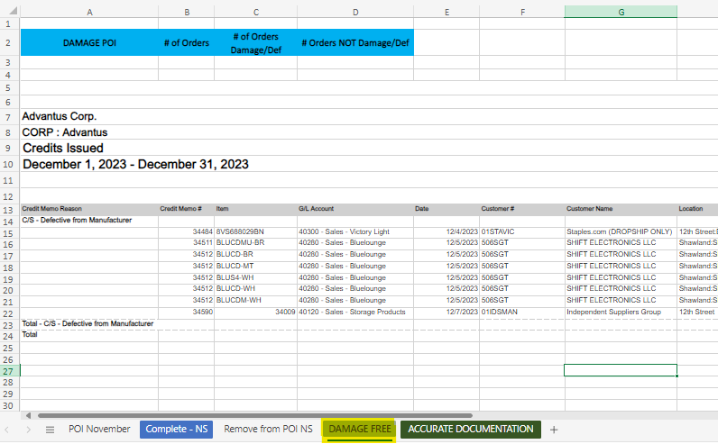

Step | Action
22 | CI pulls Total Order Count data from POI Performance YTD search for calculating month and enters that into # of Orders column on Damage Free tab of POI spreadsheet  POI Performance YTD:  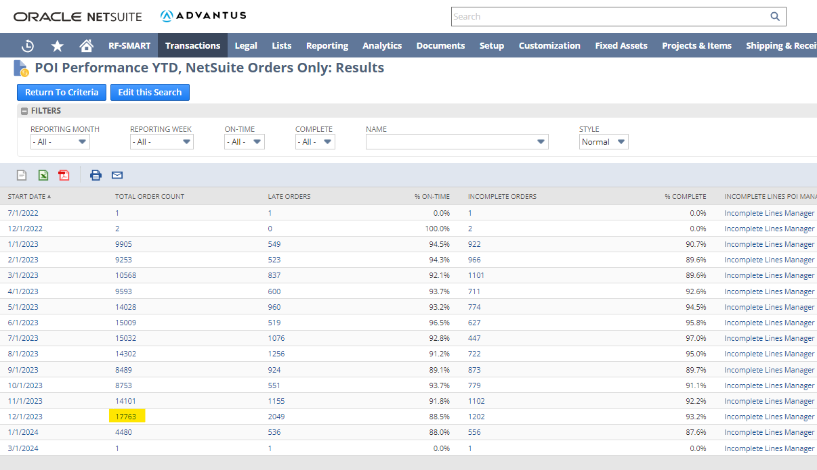  Damage Free tab:  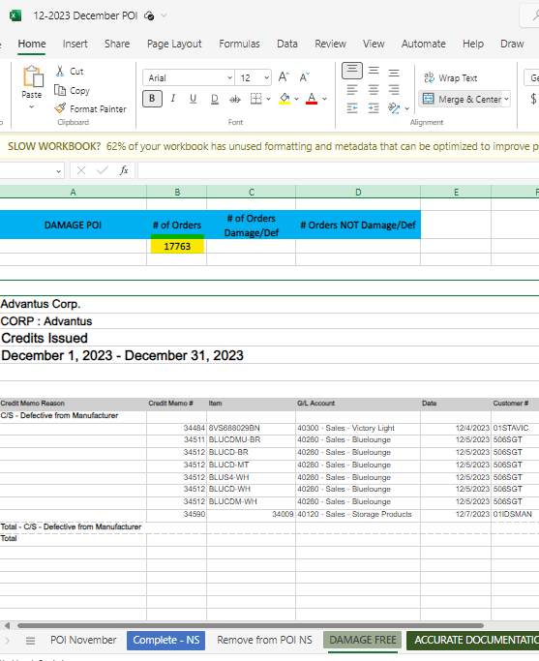

Step | Action
23 | CI reviews the number of unique credit memos that correspond to the number of orders with damage and enters that data in the # of Orders Damage/Def cell on POI spreadsheet  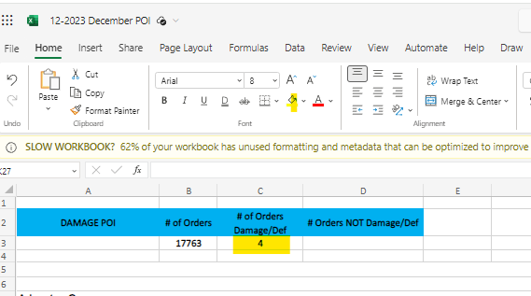
24 | POI spreadsheet formulas should then calculate # Orders NOT Damage/Def and DAMAGE POI fields  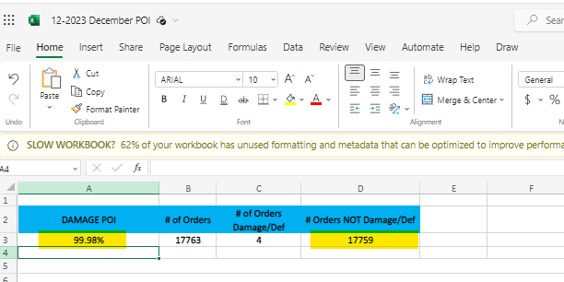
25 | CI copies DAMAGE POI data from Damage Free tab back to main POI Month tab to the monthly summary field  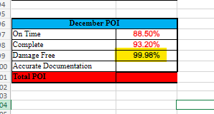
Step | Action
26 | CI accesses Compliance center, Compliance Overview in NetSuite  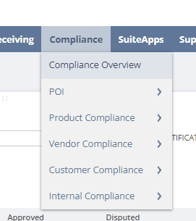
27 | CI pulls and exports to Excel all Violation Type fines related to missing or incorrect documentation for the calculating month  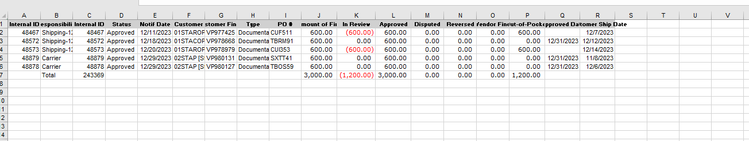  Violation Types:  - Documentation -BOL  - Documentation -CI  - Documentation _Incorrect  - Documentation – Invoice  - Documentation -Late Document  - Documentation – Packing List  - Labeling – Incorrect  - Labeling – Missing  - Labeling – Placement  - Labeling – Quality  - Vendor - Documentation  - Vendor - Labeling

Step | Action
28 | CI copies exported data onto Accurate Documentation tab of POI spreadsheet  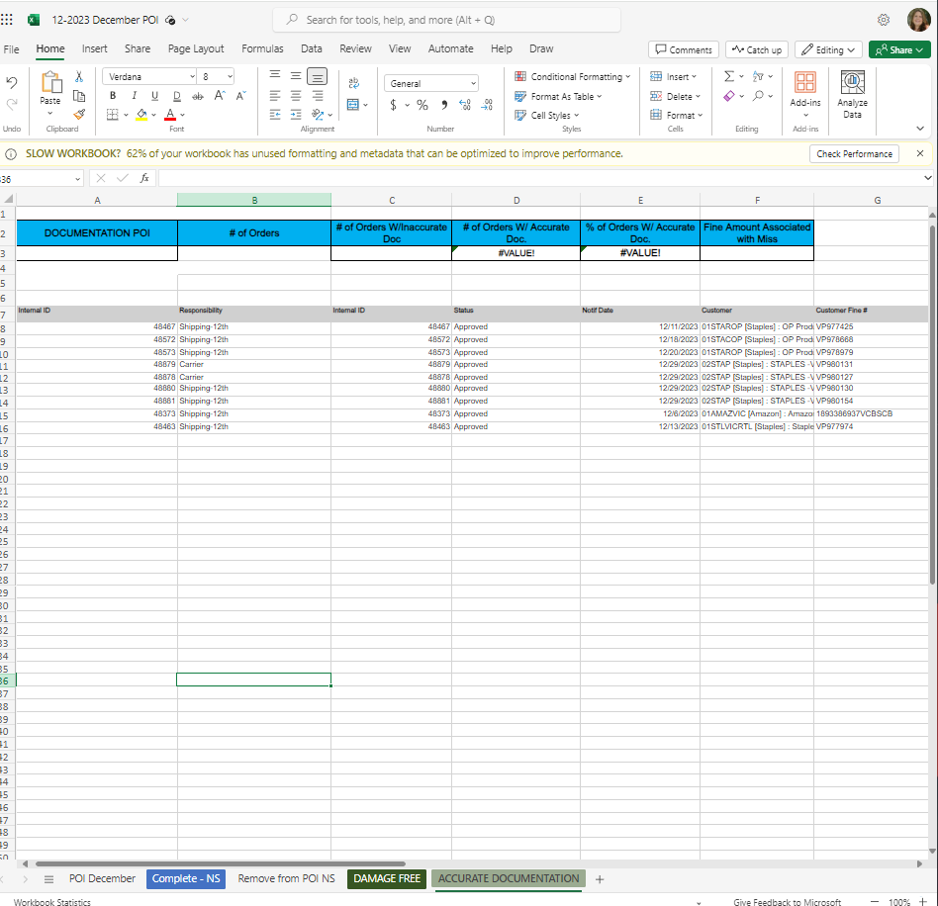
29 | CI pulls Total Order Count data from POI Performance YTD search for calculating month and enters that into # of Orders column on Accurate Documentation tab of POI spreadsheet  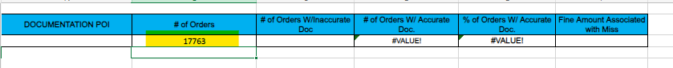
30 | CI reviews fine data and enters number of unique orders with documentation fines into # of Orders W/Inaccurate Doc column on Accurate Documentation tab of POI spreadsheet  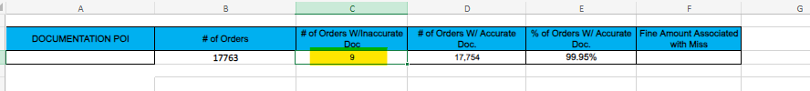

Step | Action
31 | POI spreadsheet formulas will then calculate # of Orders W/Accurate Doc and % of Orders W/Accurate Doc
32 | CI copies data in % of Orders W/Accurate Doc on Accurate Documentation tab and adds to monthly summary field on POI Month tab  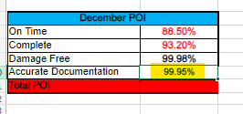
33 | CI then calculates Total POI for the month by multiplying 4 POI variables on POI Month tab  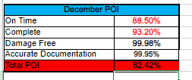
34 | CI completes YTD table with calculated month’s data on POI Month tab  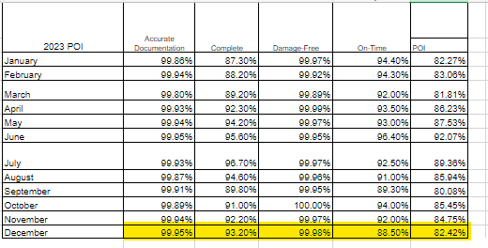

Step | Action
35 | CI fills in Total POI monthly data in line chart table on POI Month tab  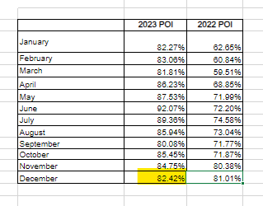

Step | Action
36 | CI creates a new email with the following data:  To: Advantus – Managers and Advantus – Dept Heads distribution lists  All Vice Presidents  All EC members  Office Administrator  Subject: POI Month Year  Body of email:  - Copy of month’s summary from POI month tab of POI spreadsheet  - Copy of POI Reason data from SCM POI Results spreadsheet  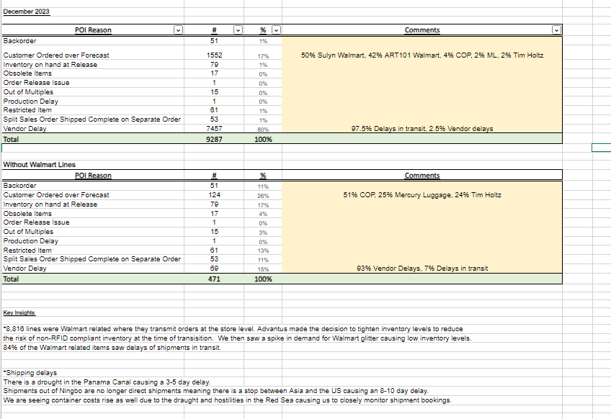
37 | CI sends the email and moves it to Sent folder of POI mailbox

