WERCSmart

Manages information for customers so they know, what chemicals are in it, how to store it and transport it. WERCSmart use the information we put in from the SDS to determine if an item is compliant.

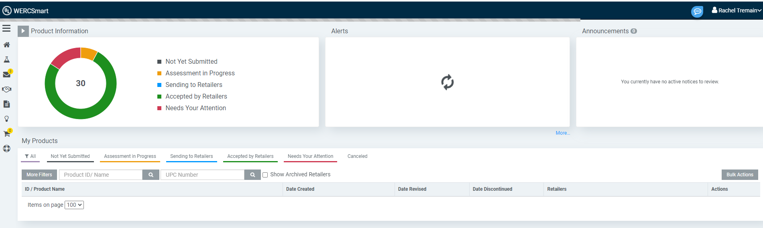

To check/change the payment methods:

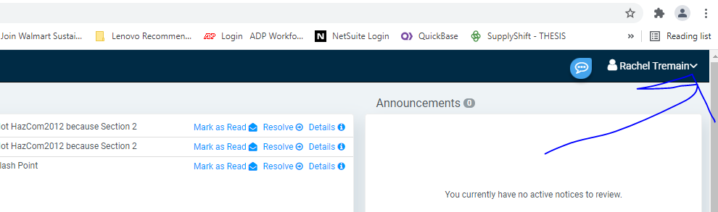

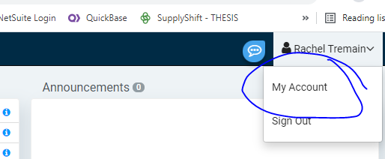

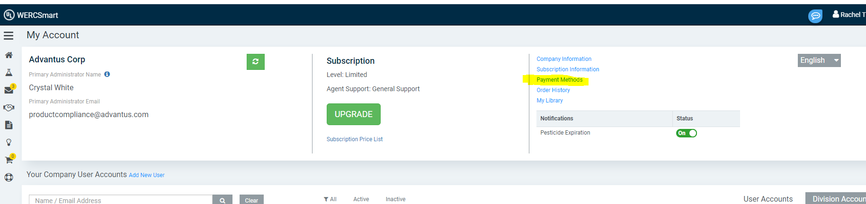

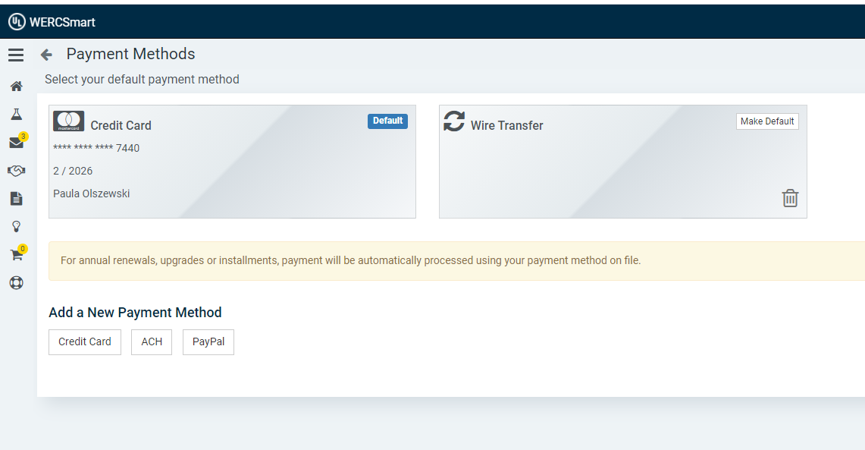

Items listed in WERCSmart will be green if they are good/accepted by retailers. Red means there is something that needs to be corrected.

Red needs attention

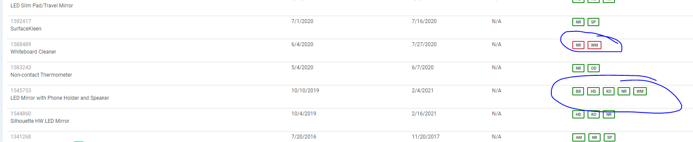

WERCSmart has SKUs and UPCs

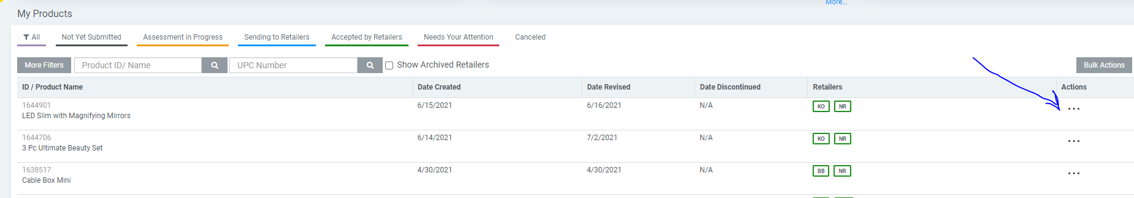

View and Update data are the most common actions

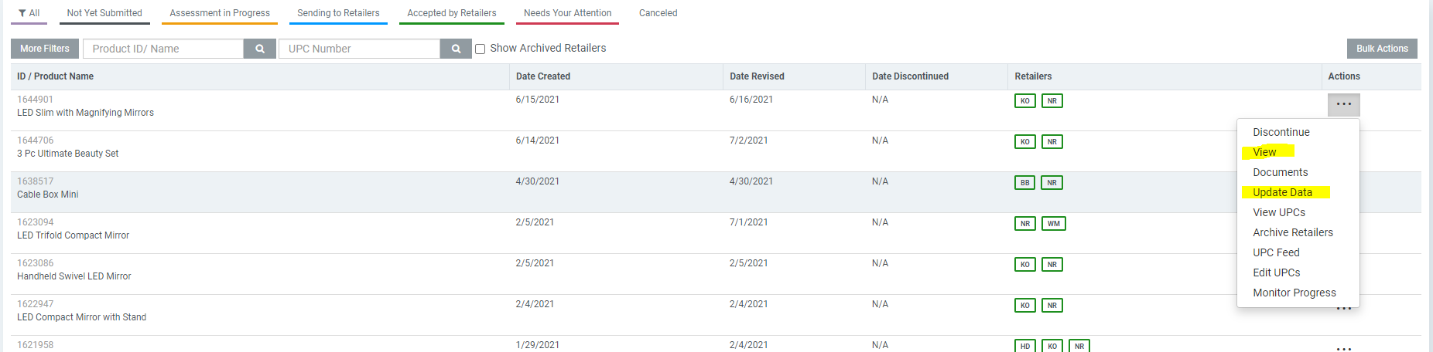

NetSuite should have the WERC ID in the Item Record (Compliance tab)

Add customer or another UPC through Update Data

Chemicals

Circuit board (Kohls, Home Depot)

Lithium batteries (Kohls, Home Depot, WM)

New Product

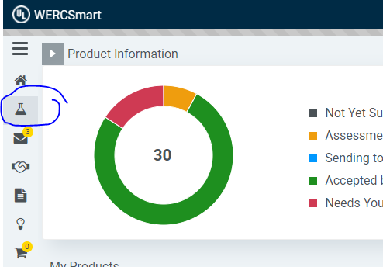

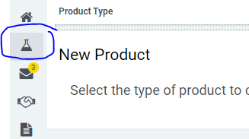

Need to have the SDS handy for making a new product

Need to have the weights

Lithium batteries in items – will need the battery WERC ID. The battery must be registered in WERC before the new item is created in WERC

* Battery WERC ID should come from the factory; and the type of battery. Request battery SDS also from factory to keep on file

For mirrors – working spreadsheet to have info WERC will need

Once a WERC ID is generated – this needs to be added to the item record in NS

Mirror info:

