Vendor Debit Memos : Compliance Fines

Vendor Debit Overview | Advantus obtains products from other vendors in order to sell to our customers. We require our vendors to operate at standards outlined by Advantus. We provide each vendor a Vendor Guide on an annual basis. This guide outlines our expectations and provides a summary of possible fines associated with a failure to meet those standards. We ask that the vendors sign an agreement advising they understand and agree to those terms.  When there is a failure in those standards by the vendor, Advantus may elect to debit the vendor a set fine. Such debits typically occur as a result of the following events:  - TRF: Failure or extra costs associated with product compliance testing  - Compliance Fine: Issue with item that resulted in a compliance fine from the Advantus customer  - Customer Reports/Feedback: Failure in item as determined by a compliant received from customer or end user  - Warehouse/Vendor Issue Task: Issue with item that resulted in a rework project by the warehouse to bring it up to the standards set

Compliance Fine: Vendor Debit Process Overview | When Advantus receives a fine from a customer, there might be occurrences that the fine is a result of an error made by the vendor. In those instances, we may decide to issue a vendor debit for the error. The Compliance Specialist will determine if the debit should be made when reviewing the fine. When a debit is required, the Compliance Specialist will:  - Enter the debit details on the Compliance Fine record in NetSuite,  - Create Vendor Debit Memo record in NetSuite,  - Forward a copy of debit memo to the vendor via email,  - Send a copy of the debit memo to accounting so they can process the vendor debit, and  - Attach copy of debit memo to the Compliance Fine record in NetSuite.  The following training will provide the steps on issuing a vendor debit for Compliance fines.
- Continued on next page
Vendor Debit Memos : Compliance Fines, Continued

Vendor Debit: Compliance Fine  Instructions | The following steps outline the vendor debit process as a result of a fine.  Step Action  1 Access the Compliance Fine record in Edit mode 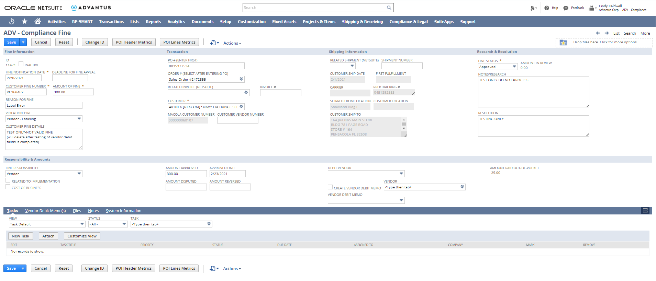  2 Select Yes in drop down of Debit Vendor field 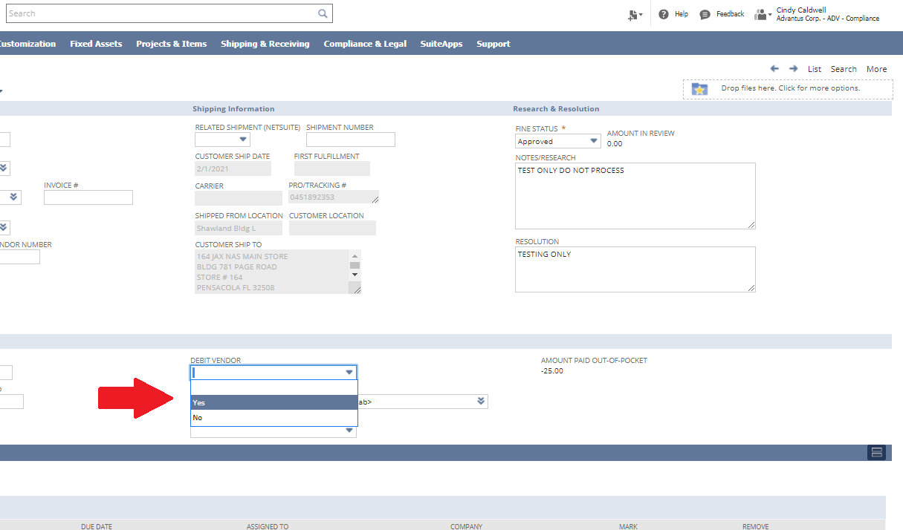
Continued on next page
Vendor Debit Memos : Compliance Fines, Continued

Vendor Debit: Compliance Fine  Instructions, continued | Step Action  3 Check the box beside Create Vendor Debit Memo field 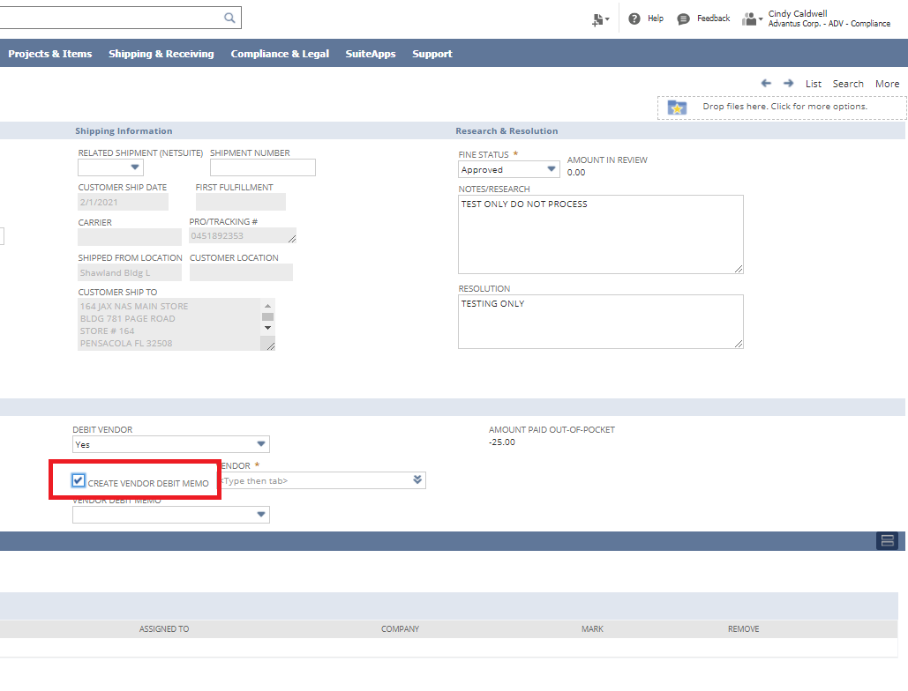  4 Type in vendor number to be debited in Vendor field 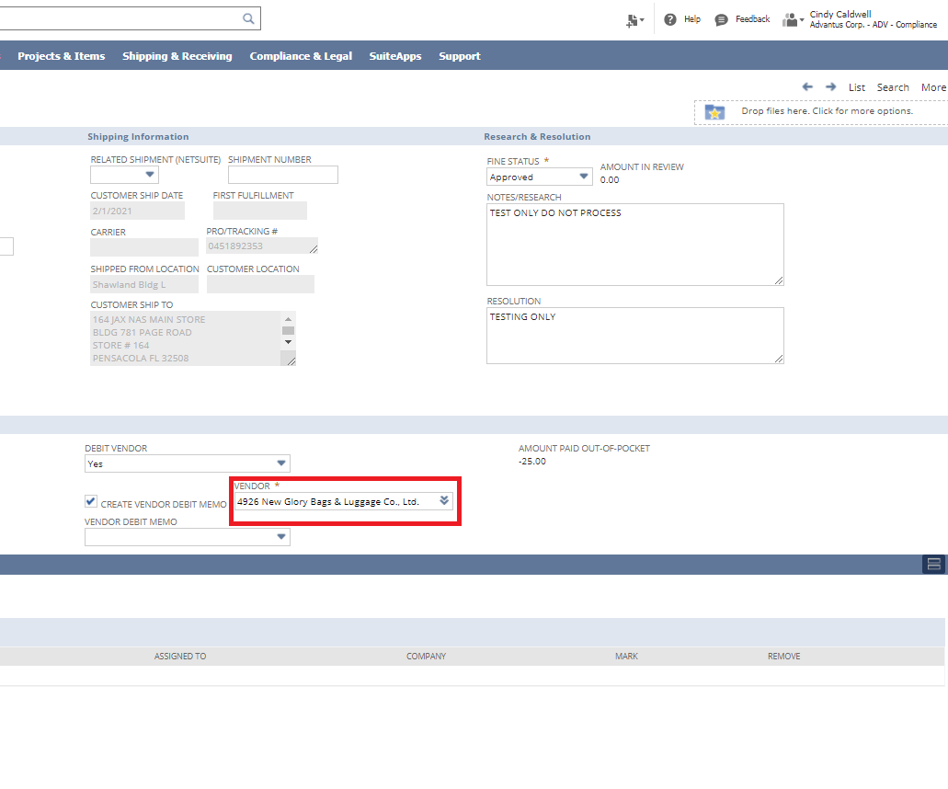 Note: Vendor number can be found on the Item record.
Continued on next page
Vendor Debit Memos : Compliance Fines, Continued

Vendor Debit: Compliance Fine  Instructions, continued | Step Action  5 Select Save option to update Compliance Fine 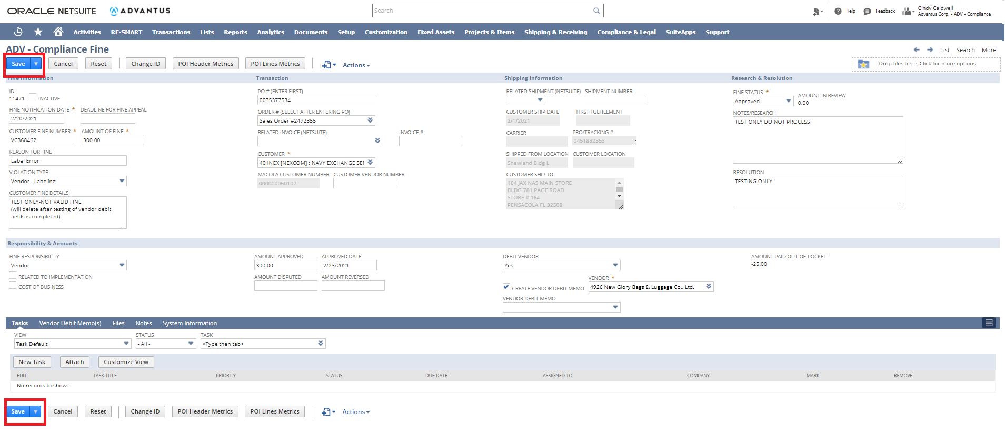  6 System will display created Vendor Debit Memo record in Edit mode 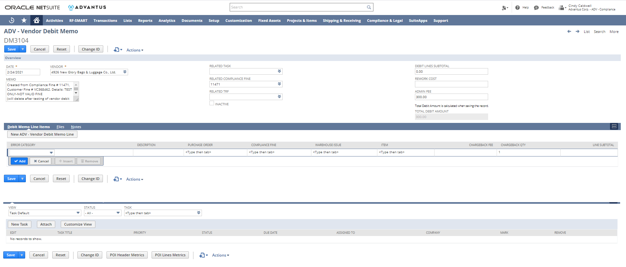
Continued on next page
Vendor Debit Memos : Compliance Fines, Continued

Vendor Debit: Compliance Fine  Instructions, continued | Step Action  7 Confirm all the header fields are filled in correctly from fine 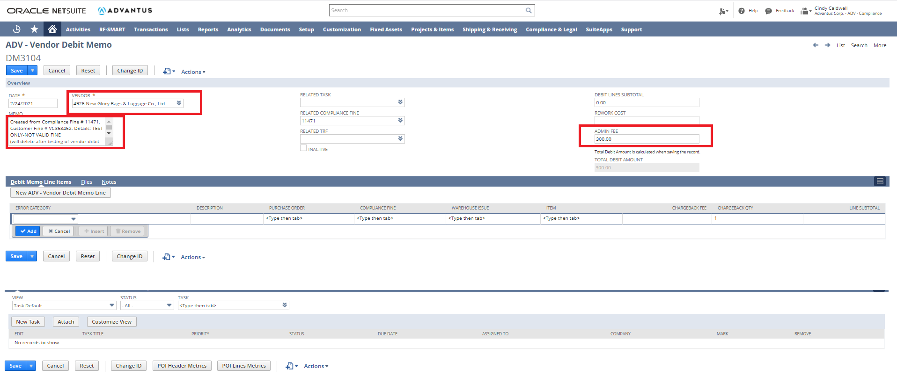  8 Complete the Error Category field using the drop down option 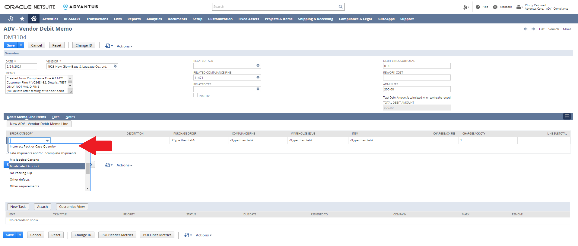
Continued on next page
Vendor Debit Memos : Compliance Fines, Continued

Vendor Debit: Compliance Fine  Instructions, continued | Step Action  9 System will fill in standard fee in Chargeback Fee field 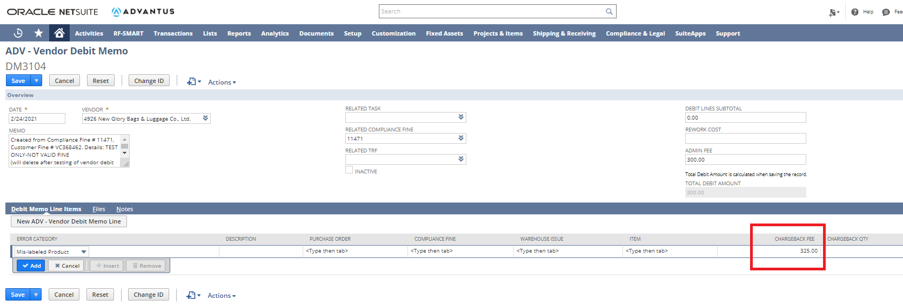  10 Confirm Chargeback Qty field is correct or update it 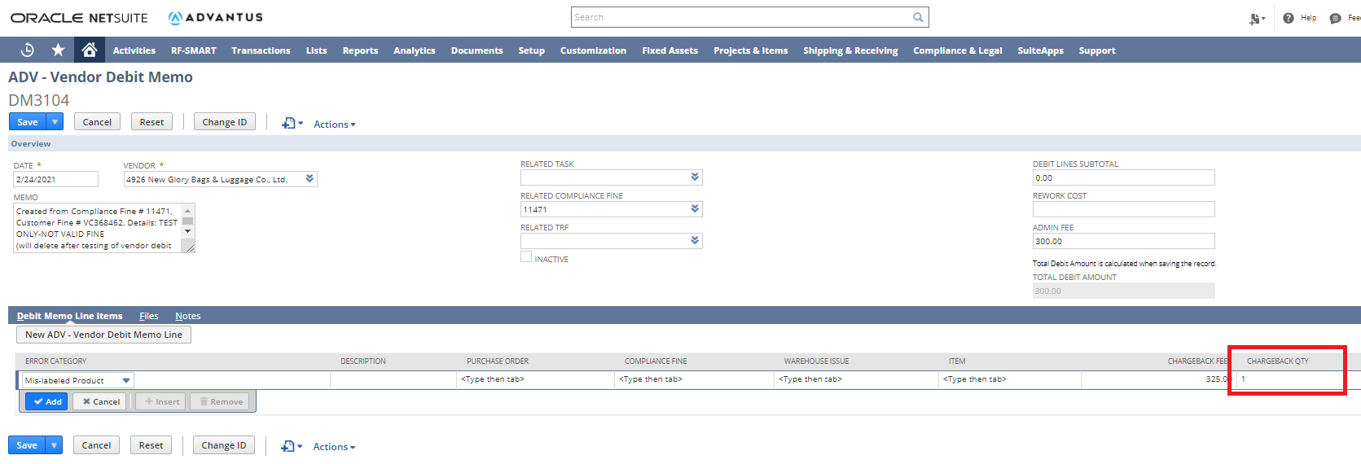
Continued on next page
Vendor Debit Memos : Compliance Fines, Continued

Vendor Debit: Compliance Fine  Instructions, continued | Step Action  11 Select Add option to add Debit Memo Line Item 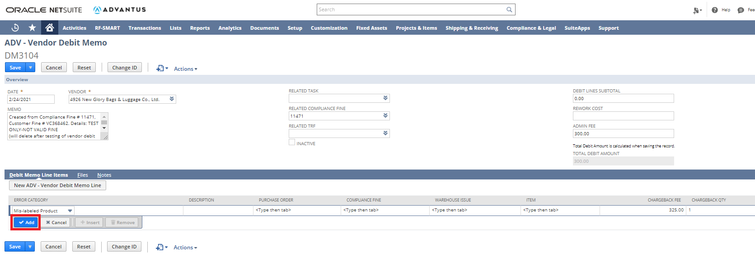  12 System will add new item line, repeat Steps 8-11 until all errors are added to Vendor Debit Memo record 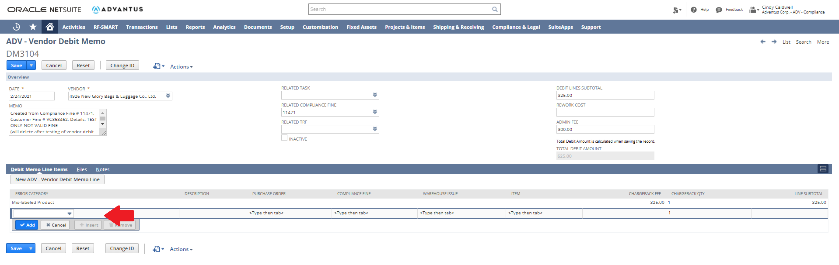
Continued on next page
Vendor Debit Memos : Compliance Fines, Continued

Vendor Debit: Compliance Fine  Instructions, continued | Step Action  13 Once all lines are added, confirm Debit Lines Subtotal is correct 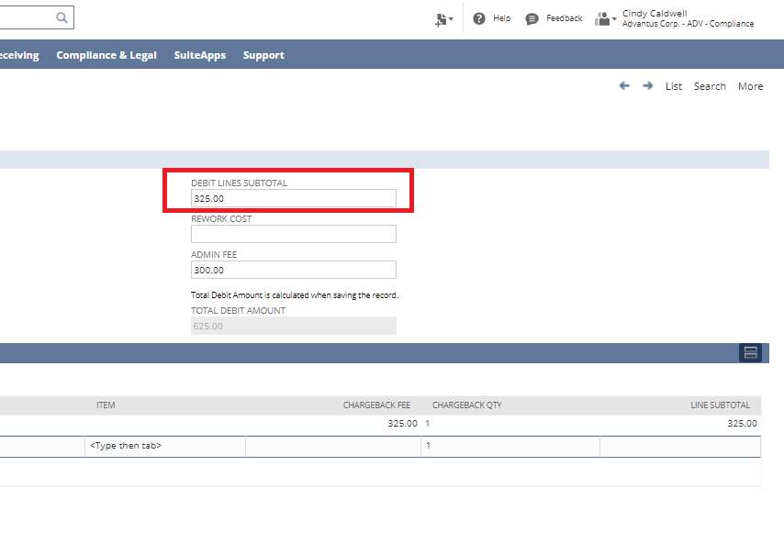  14 Select Save option 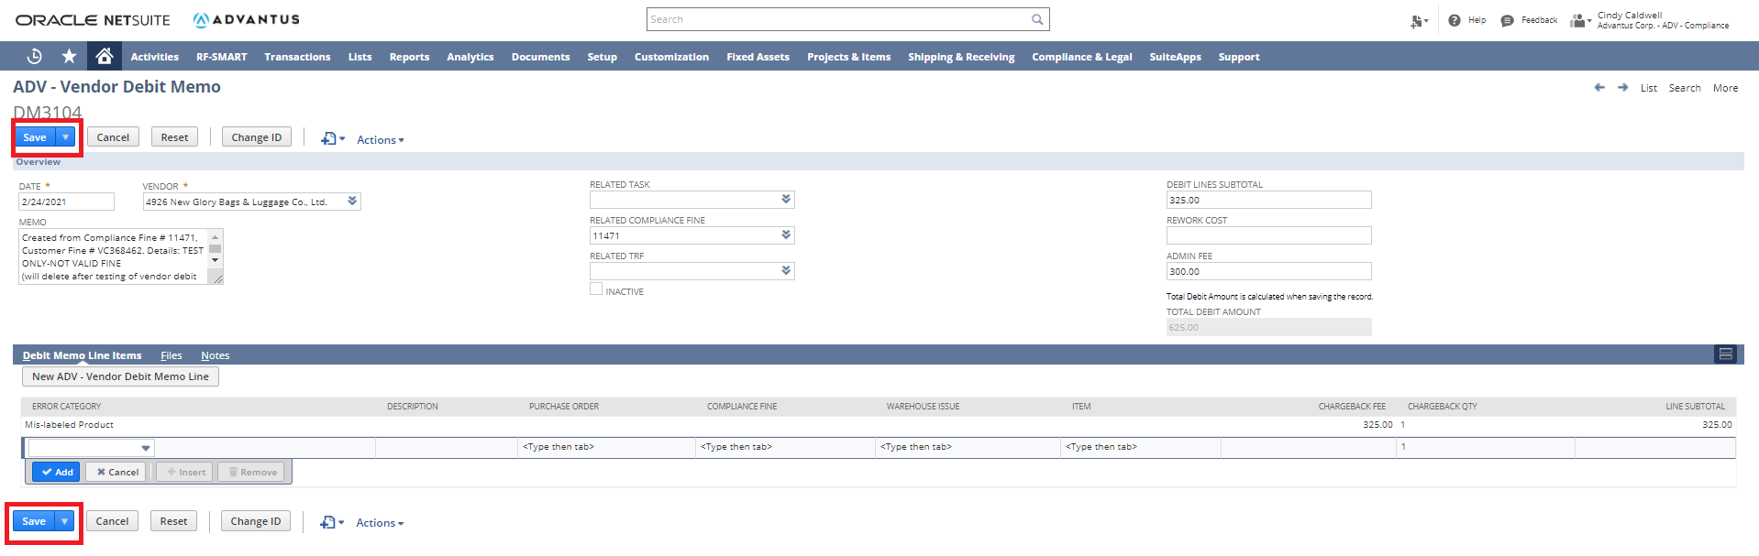
Continued on next page
Vendor Debit Memos : Compliance Fines, Continued

Vendor Debit: Compliance Fine  Instructions, continued | Step Action  15 System will save updates to Vendor Debit Memo record 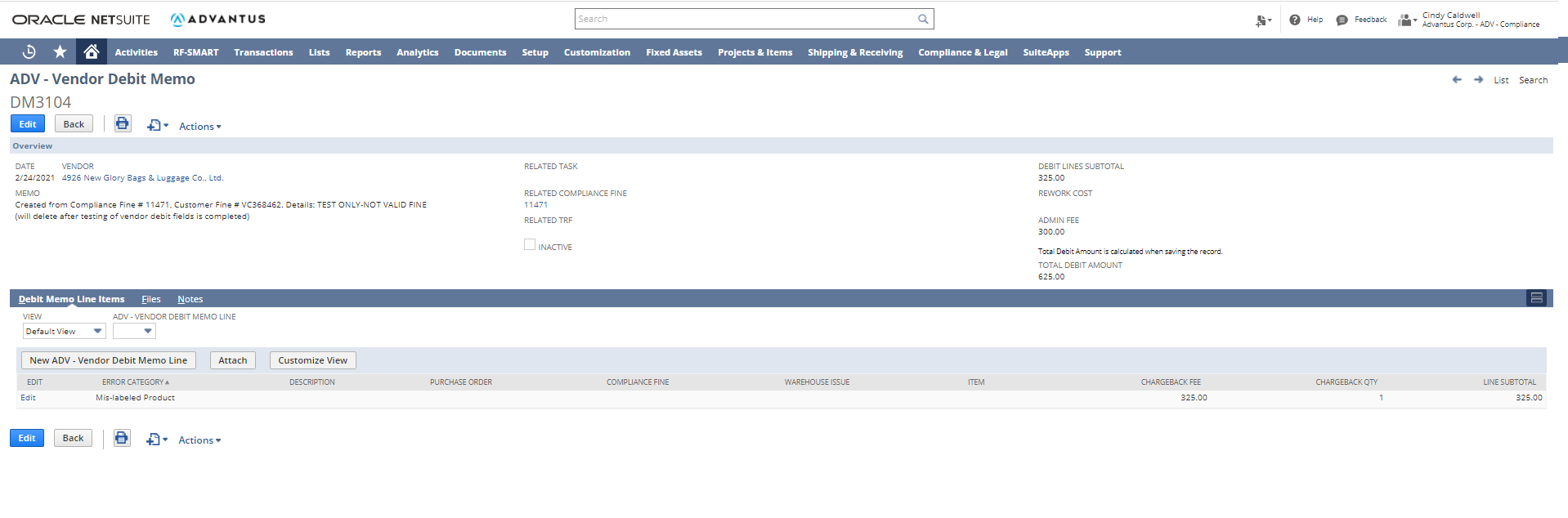  16 Click the print icon () to generate PDF version of memo 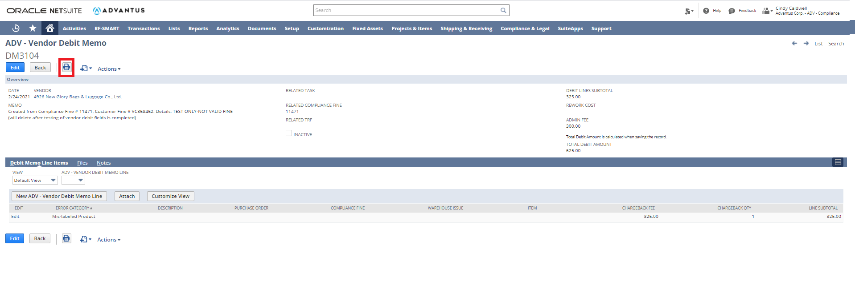
Continued on next page
Vendor Debit Memos : Compliance Fines, Continued

Vendor Debit: Compliance Fine  Instructions, continued | Step Action  17 System displays PDF of debit memo 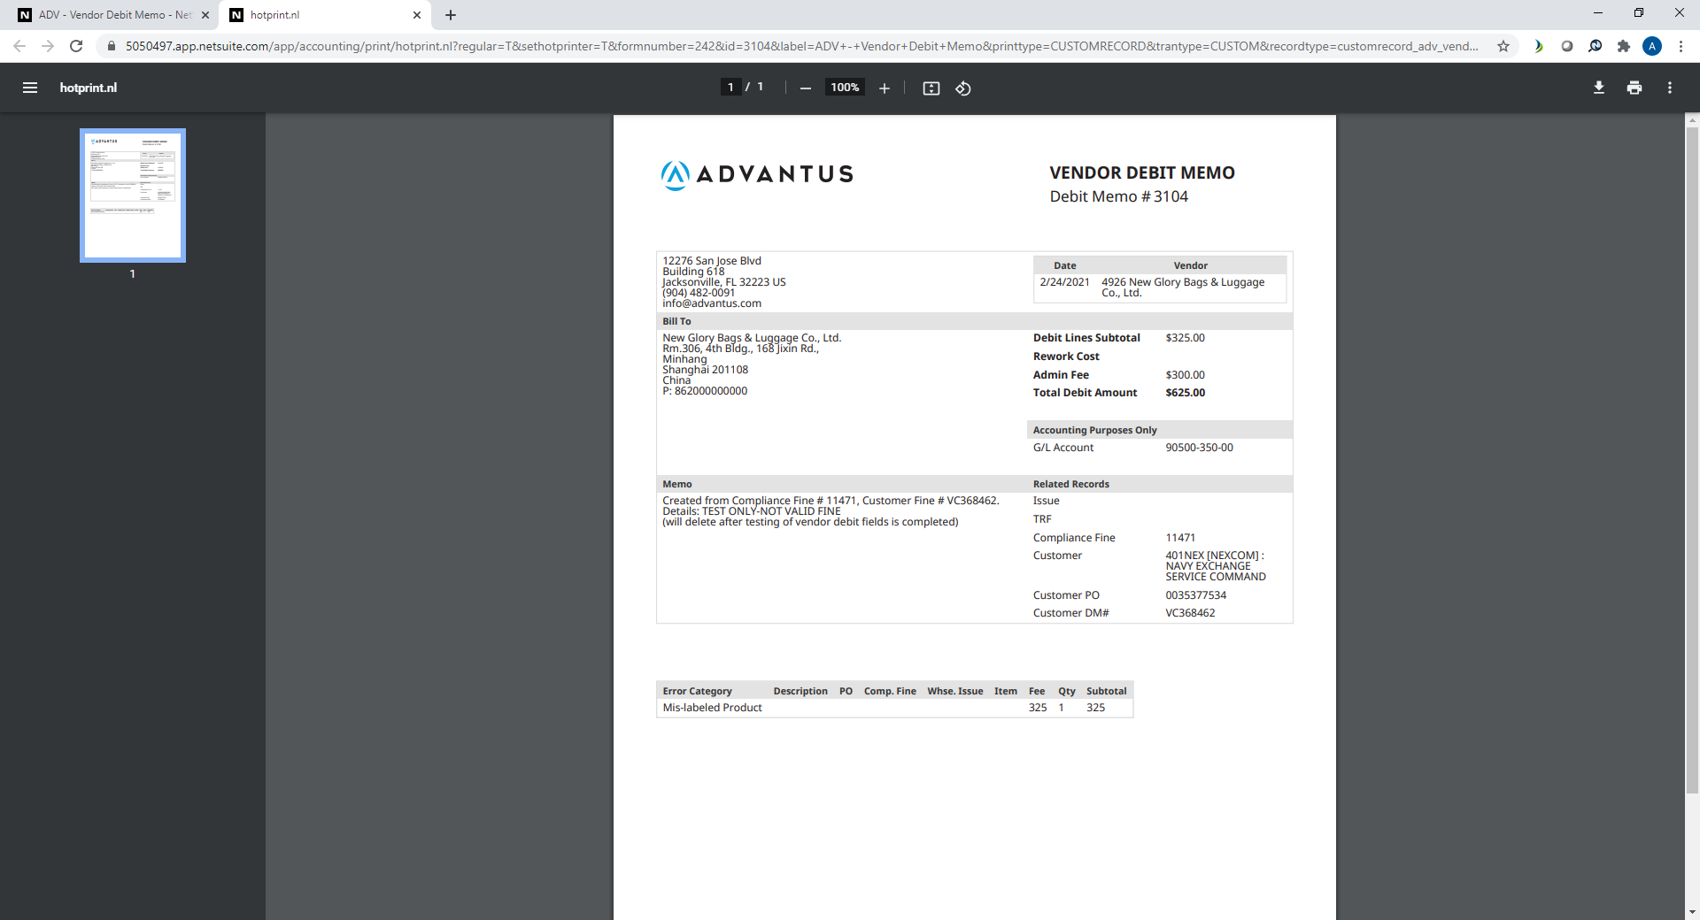  18 Save PDF to share drive Compliance-Vendor Compliance-Vendor Debit Memos-YYYY folder  19 Email copy of PDF memo to the vendor using the contact details in NetSuite and cc: ap@advantus.com for accounting to process debit  20 Access Compliance Fine record to attach PDF of debit memo using Drag and Drop feature. 