**Setting up multiple new items in Vendor Central that don’t have ASINs**

1. Log into Amazon Vendor Central portal
2. At the top of the page, hover over “Items”
3. Select **“Add Products”** from the dropdown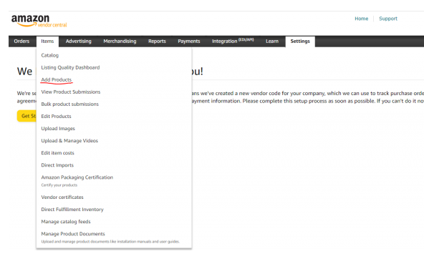
4. On the Add Products page, select “**Select Product Type**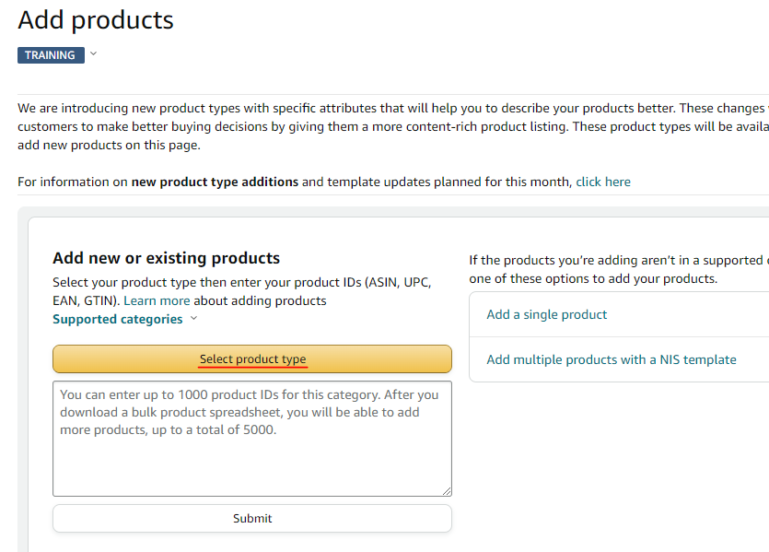
5. A pop-up box will appear, choose the appropriate category for the product. **Note- if adding several items in bulk, this may need to be done multiple times if there is more than 1 product type for the items being added.** 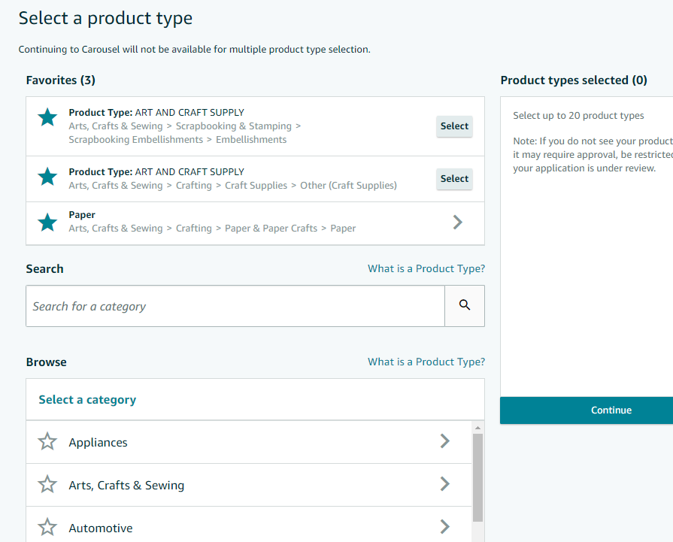
6. Once product category is selected, enter **product ID (can be UPC, GTIN or item #)** in text box. 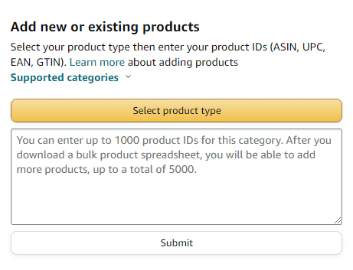
7. You can then click submit or select the option to download a blank spreadsheet (specific to the product category that was just selected.
8. Once all required fields are filled in for all new items being added, upload in the bulk product submissions section. 