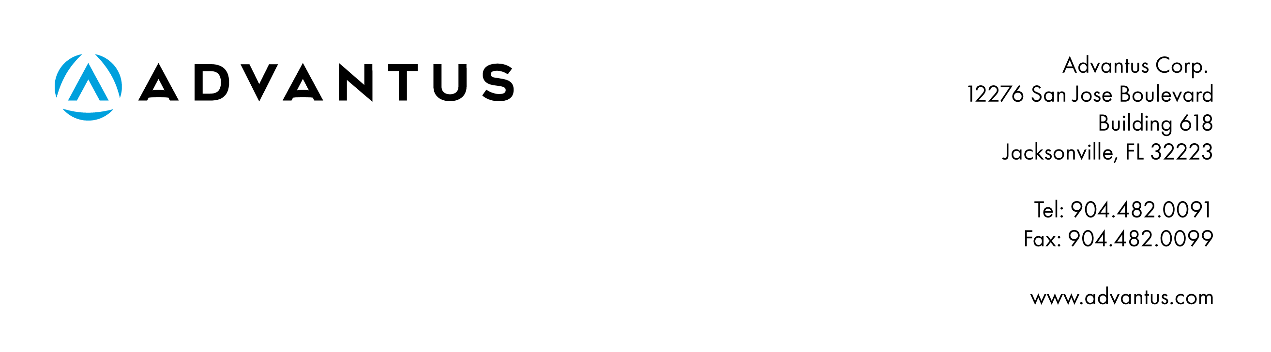**Letter of Guarantee**

**TEMPLATE**

Month Day, Year

To Whom It May Concern,

This letter confirms that the following item(s) that is/are shipped to Name of Customer is/are made of the same material, at the same factory, with an alternative product item number (Alt Item Number).

|  |  |  |  |
| --- | --- | --- | --- |
| ASIN | Item Number | Description | Alt Item Number |
| Enter # | List Customer specific item number(s) | Detail Product Name(s) | List item number from referenced report |

This item was tested under Name of Lab Report Number: XXXXX and (if applicable include the TRA/LHAMA was conducted on *(name of lab)* Report Number: XXXXXX.

*Advantus redacts business proprietary information associated with contractors or vendors. This information is not relevant to the review of the tests performed or testing results.*

Best regards,

First and Last Name

Title